Campaign Details
Campaign Name | Dreamworks ads plan Microsoft Surface go
Objective/Goal: [Choose from Facebook's ad objectives, e.g., Reach, Engagement, Conversions, etc.] | Brand awareness/ Engagement Ads
Special Ad Categories
Campaign products | All product categories and subsidiaries
Budget & Schedule | N40,000
Daily Budget | N 2000
Ad Set Schedule | 2 weeks
Ad placement | Instagram Platforms
Endpoint | Get inquiries for products customers can pay for over time.
Notes.
Content type | Video/image content.
Caption | The Microsoft Surface Go has a 10-inch 3:2 screen with 1800x1200 pixels resolution, protected with Corning Gorilla Glass 3.  The system is powered by a 1.6 GHz Intel Pentium 4415Y processor, 8 GB of RAM, and 128 GB of storage (there is a cheaper version with 4GB RAM and 64GB storage) and is powered by Windows 10, the Microsoft Surface Go 2 empowers you to live life from wherever you need to work with its compact 2 in 1 design.⁣  ⁣  Shop now via DM, or contact 09070402023  .  Grab this amazing offer now now!!  ⁣  ⁣⁣  #DreamWorksNig #mobilegadgets #laptopgadgets #lagosgadgetstore #gadgetstores #ShopSmart #microsoft #surfacego
Video linke | https://www.instagram.com/reel/C7Etiafift0/

Campaign Details
Campaign Name | Dreamworks ads plan Microsoft Surface go
Objective/Goal: [Choose from Facebook's ad objectives, e.g., Reach, Engagement, Conversions, etc.] | Sales advert
Special Ad Categories
Campaign products | All product categories and subsidiaries
Budget & Schedule | N40,000
Daily Budget | N 2000
Ad Set Schedule | 2 weeks
Ad placement | Instagram Platforms
Endpoint | Get inquiries for products customers can pay for over time.
Notes.
Content type | Image
Caption | The Microsoft Surface Go has a 10-inch 3:2 screen with 1800x1200 pixels resolution, protected with Corning Gorilla Glass 3.  The system is powered by a 1.6 GHz Intel Pentium 4415Y processor, 8 GB of RAM, and 128 GB of storage (there is a cheaper version with 4GB RAM and 64GB storage) and is powered by Windows 10, the Microsoft Surface Go 2 empowers you to live life from wherever you need to work with its compact 2 in 1 design.⁣  All for N300,000.  ⁣  Shop now via DM, or contact 09070402023  Grab this amazing offer now now!!  ⁣  ⁣⁣  #DreamWorksNig #mobilegadgets #laptopgadgets #lagosgadgetstore #gadgetstores #ShopSmart #microsoft #surfacego
Image | 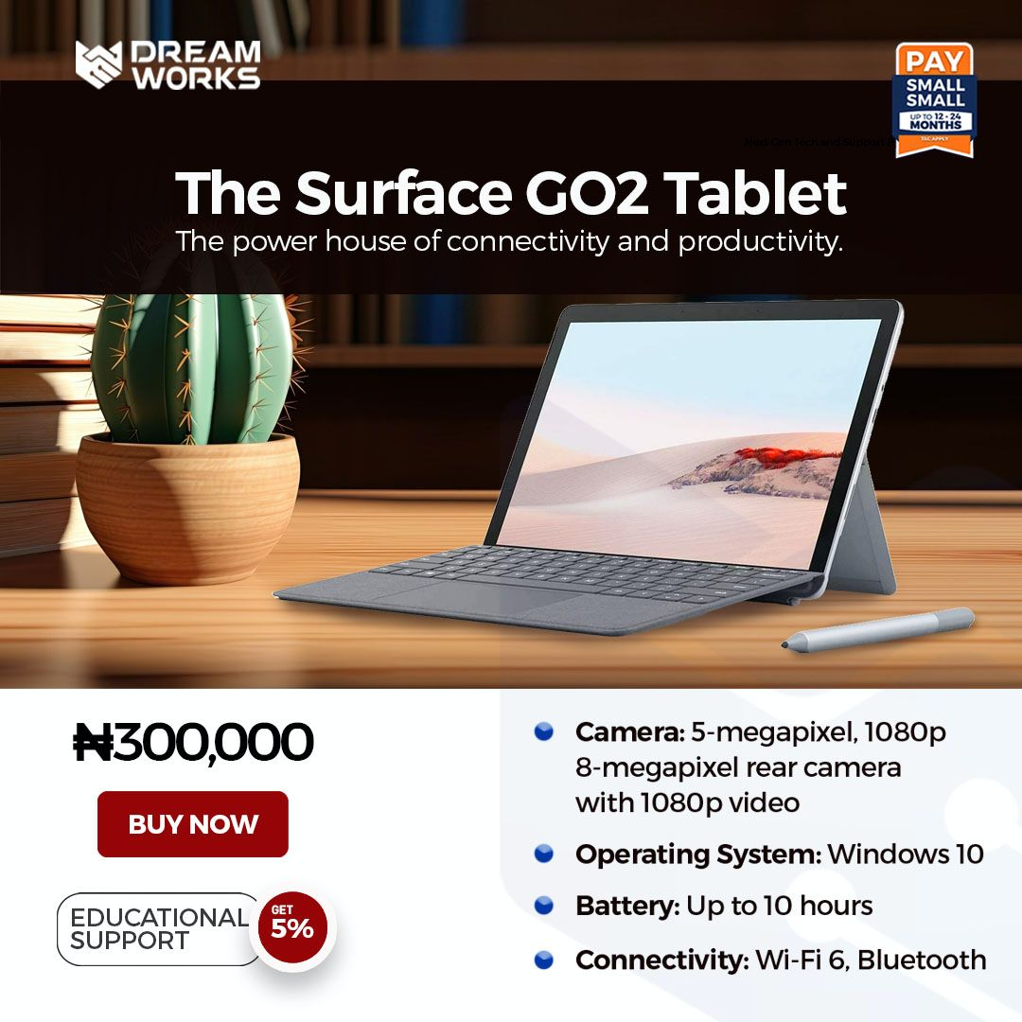

Ad cost total | N80,000

